
COMP301
Software Design
Confidence Agent
Static Verification of API Hallucinations
In LLM-Generated Code
Progress Report 2

An investigation into how thoughtful
software design can improve the
trustworthiness of AI systems through
benchmark design, experimental
methodology, validation architectures,
and evidence-based evaluation.

by The Skeptics

University of
KwaZulu-Natal

Project Formalities

Domain
Static Verification of API Hallucinations In LLM-Generated Code
Group Name: The Skeptics
Group Members:
Member Name | Student Number
Jawad Kachbal | 223037045
Joshua Blom | 224039813
Mahomed Valli Mahomed | 224005878
Andiswa Hlengwa | 221002430
Abiel Govender | 224058851

Table of Contents
Project Formalities 1
Progress Report 2
Overview 2
Architecture Design 2
Baseline 2
Confident Agent 2
Environment Setup 2
Application Domain Status 3
Group Task Allocation 3
Next Steps 3
Architecture Diagrams 3
Baseline flow 4
Confident Agent flow 4

Progress Report

COMP301 — Confident Agent
Progress Report
The Skeptics — University of KwaZulu-Natal

Overview
This report summarises the group's progress to date on the Confident Agent project. Work so far has focused on defining the comparative architecture between the baseline model and the proposed Confident Agent, setting up a local model environment for experimentation, and dividing the group's initial research workload.

Architecture Design
The group has agreed on the general comparative structure between the baseline system and the Confident Agent, keeping the system prompt fixed across both conditions to isolate the effect of the verification architecture.

Baseline
A fixed system prompt is defined and sent to the model together with the user's query. The model's response is returned directly to the user with no intervention or verification.

Confident Agent
The same fixed system prompt is used, and the user still interacts directly with the model. However, before the response reaches the user, it is intercepted and passed through the Confident Agent's verification architecture. The current working design is a multi-agent pipeline, in which the model's draft response is checked by two to three smaller, specialised verification agents before being released to the user (or flagged/withheld if it fails verification).
Candidate verification agents under consideration:
- Web search agent — cross-checks factual claims in the response against live web results.
- Documentation/knowledge-source agent — verifies claims (e.g. API usage, technical facts) against authoritative reference material for the chosen domain.
- Execution / sandbox agent — where applicable (e.g. code or software-related domains), runs or tests the claim in a sandboxed environment to confirm it behaves as described.
Note: the exact composition and ordering of verification agents is still being finalised and will depend on the application domain ultimately selected.

Environment Setup
LM Studio has been installed and configured to run models locally with tooling, allowing the group to experiment without incurring API costs during development. A local model, Qwen3.6 9B (Q8.0 quantisation), is currently running and being used for early testing of the verification pipeline concept.

Application Domain Status
The group's originally proposed application domain and approach were reconsidered after establishing that the tooling available to the model (e.g. web browsing, Wikipedia access) could trivially resolve the intended hallucination scenarios, undermining the validity of the benchmark. As a result, the application domain remains under review. Importantly, the group has established that the underlying multi-agent verification architecture is largely domain-agnostic and is expected to generalise across candidate domains — for example, in a software-focused domain, verification agents could check a response against official documentation, cross-reference it via the web, and execute it in a sandbox to confirm correctness.

Group Task Allocation
Member(s) | Current Focus
Abiel Govender & Andiswa Hlengwa | Formal definition of an LLM hallucination and the underlying causes of hallucination.
Mahomed Valli Mahomed | What constitutes an LLM agent, and the rationale for using one in this context.
Joshua Blom | Multi-agent systems and mechanisms for inter-agent interaction.
Jawad Kachbal | Environment setup, tool creation, and application domain research.

Next Steps
- Finalise the application domain based on ongoing research.
- Consolidate individual research findings into a shared understanding of hallucination causes, agent design, and multi-agent interaction.
- Begin construction of the hallucination benchmark for the selected domain.
- Prototype the verification agent pipeline using the local Qwen3.6 model in LM Studio.

Architecture Diagrams
The diagrams below illustrate the baseline flow and the proposed Confident Agent flow, corresponding to the architecture described in Section 2. There is an idea of producing a confidence metric (ie – 92%), however, discussions are in place on how exactly we would do this.

Baseline flow
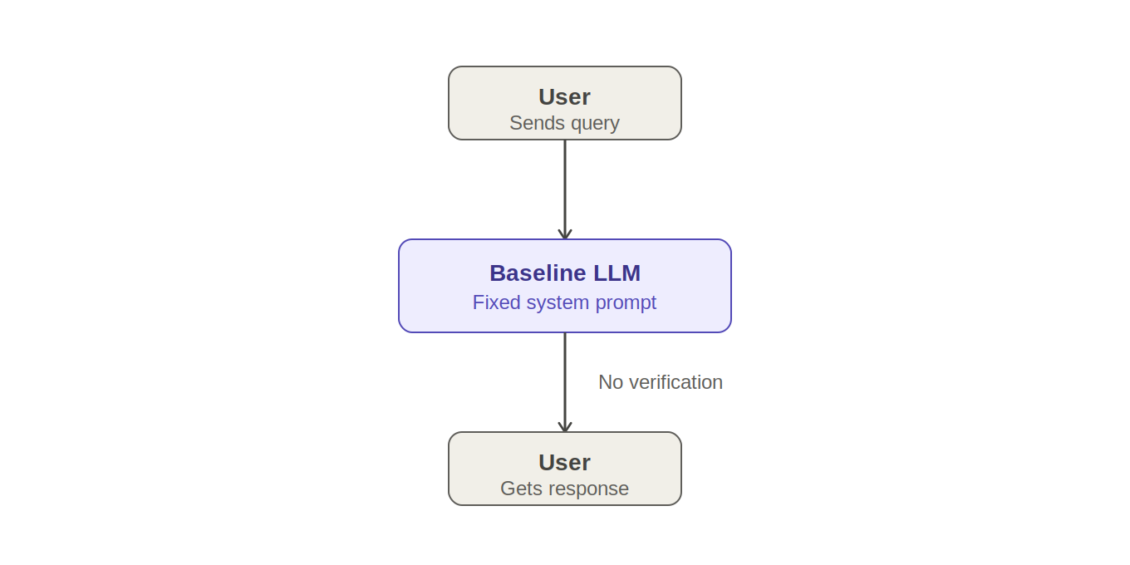

Confident Agent flow
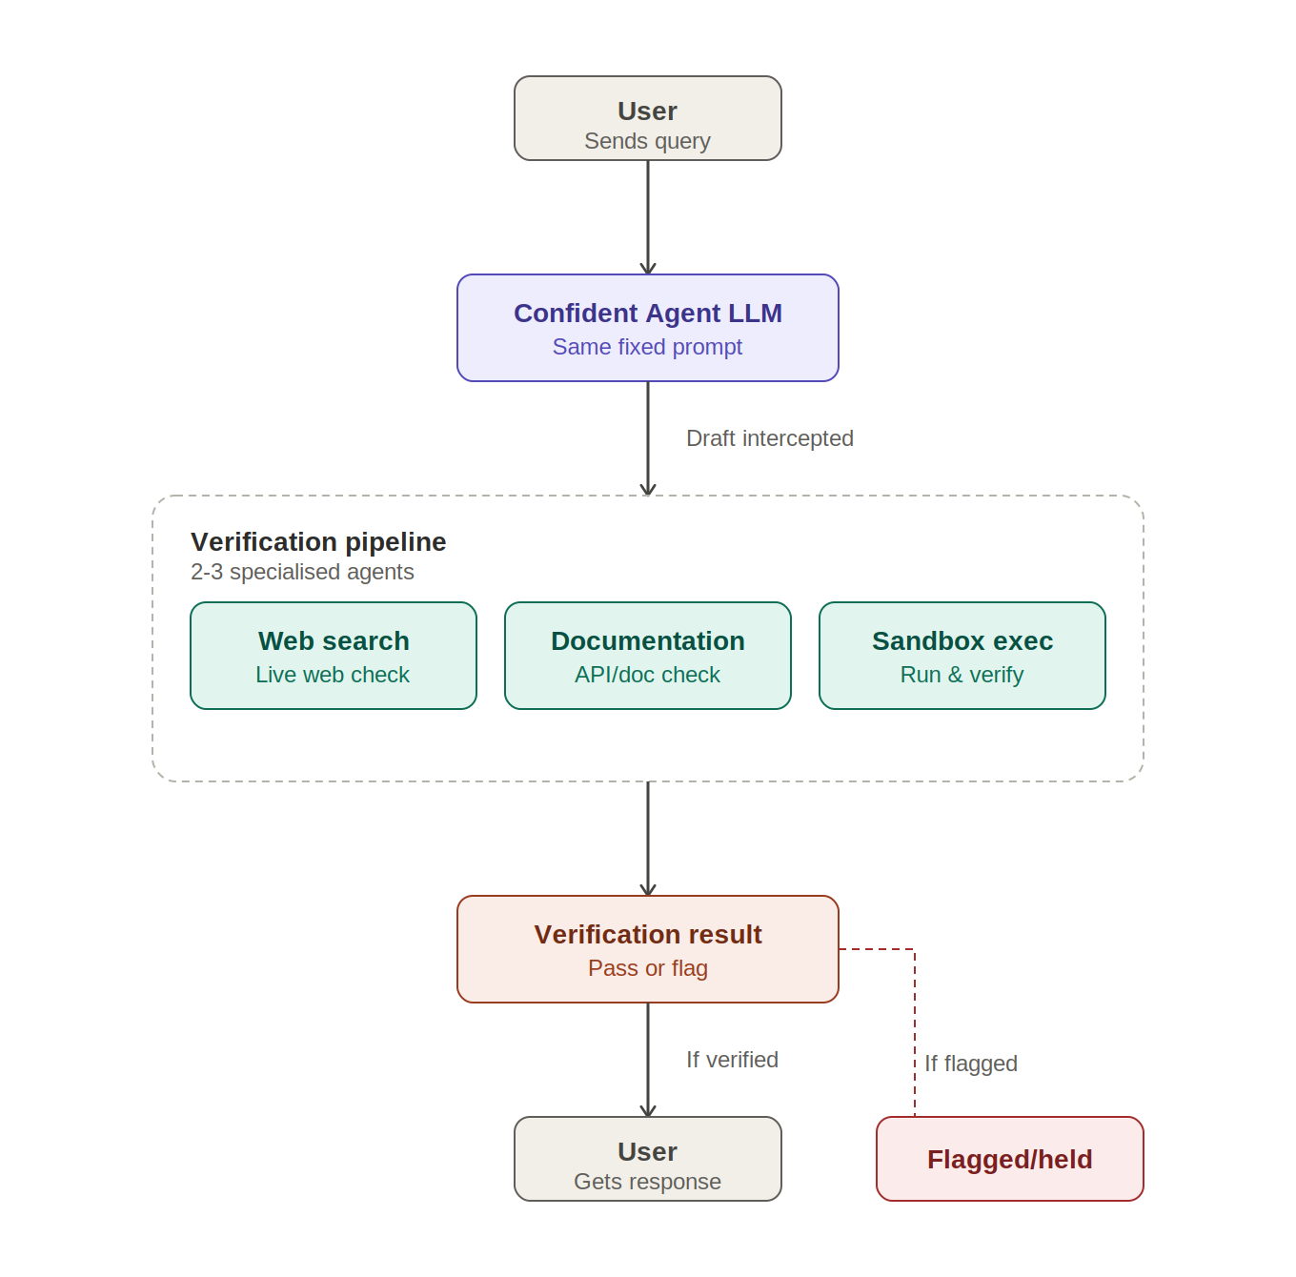

AI was used in the compilation of this report, however all ideas contained within were initially discussed by our group before being “polished”.

